

# 

### Semester One Examination, 2017

### Question/Answer booklet

# MATHEMATICS

If required by your examination administrator, please place your student identification label in this box

**APPLICATIONS**

**UNIT 3**

## Section Two:

## Calculator-assumed

|  |  |  |  |  |  |  |  |  |  |  |
| --- | --- | --- | --- | --- | --- | --- | --- | --- | --- | --- |
| Student Number: In figures |  |  |  |  |  |  |  |  |  |  |

In words

Your name

## Time allowed for this section

Reading time before commencing work: ten minutes

Working time: one hundred minutes

## Materials required/recommended for this section

***To be provided by the supervisor***

This Question/Answer booklet

Formula sheet (retained from Section One)

***To be provided by the candidate***

Standard items: pens (blue/black preferred), pencils (including coloured), sharpener, correction fluid/tape, eraser, ruler, highlighters

Special items: drawing instruments, templates, notes on two unfolded sheets of A4 paper, and up to three calculators approved for use in this examination

## Important note to candidates

No other items may be taken into the examination room. It is **your** responsibility to ensure that you do not have any unauthorised material. If you have any unauthorised material with you, hand it to the supervisor **before** reading any further.

## Structure of this paper

|  |  |  |  |  |  |
| --- | --- | --- | --- | --- | --- |
| Section | Number of questions available | Number of questions to be answered | Working  time (minutes) | Marks available | Percentage of examination |
| Section One:  Calculator-free | 7 | 7 | 50 | 52 | 35 |
| Section Two:  Calculator-assumed | 11 | 11 | 100 | 98 | 65 |
|  | | |  | **Total** | 100 |

## Instructions to candidates

1. The rules for the conduct of examinations are detailed in the school handbook. Sitting this examination implies that you agree to abide by these rules.

2. Write your answers in this Question/Answer booklet.

3. You must be careful to confine your response to the specific question asked and to follow any instructions that are specified to a particular question.

4. Additional working space pages at the end of this Question/Answer booklet are for planning or continuing an answer. If you use these pages, indicate at the original answer, the page number it is planned/continued on and write the question number being planned/continued on the additional working space page.

5. Show all your working clearly. Your working should be in sufficient detail to allow your answers to be checked readily and for marks to be awarded for reasoning. Incorrect answers given without supporting reasoning cannot be allocated any marks. For any question or part question worth more than two marks, valid working or justification is required to receive full marks. If you repeat any question, ensure that you cancel the answer you do not wish to have marked.

6. It is recommended that you do not use pencil, except in diagrams.

7. The Formula sheet is not to be handed in with your Question/Answer booklet.

Section Two: Calculator-assumed 65% (98 Marks)

This section has**eleven (****11)** questions. Answer **all** questions. Write your answers in the spaces provided.

Working time: 100 minutes.

Question 8 (6 marks)

The weight, $W_{n}$ kg, of flour produced by a mill that needs to be sent to the packing department is given by $W_{n+1}=W_{n}+1.25, W_{0}=7.5$, where $n$ is the number of minutes after 5 am.

(a) Complete the table below. (2 marks)

|  |  |  |  |  |  |  |
| --- | --- | --- | --- | --- | --- | --- |
| $$n$$ | $$0$$ | $$1$$ | $$2$$ | $$3$$ | $$4$$ | $$5$$ |
| $$W_{n}$$ | $$7.5$$ |  |  |  |  |  |

(b) Calculate the weight of flour at 6 am. (2 marks)

(c) At what time will the weight of flour reach 150 kg? (2 marks)

Question 9 (13 marks)

Agricultural researchers collected data on the amount of rainfall ( $x$ mm) and the yield of cucumbers ( $y$ kg per square metre) over several seasons at a farm. Some of their data is shown in the table and scatterplot below.

|  |  |  |  |  |  |  |  |  |  |  |  |  |
| --- | --- | --- | --- | --- | --- | --- | --- | --- | --- | --- | --- | --- |
| Rainfall, $x$ | 22 | 84 | 97 | 48 | 14 | 37 | 97 | 50 | 61 | 75 | 36 | 6 |
| Yield, $y$ | 0.36 | 0.72 | 0.66 | 0.21 | 0.11 | 0.54 | 0.66 | 0.56 | 0.42 | 0.61 | 0.31 | 0.09 |

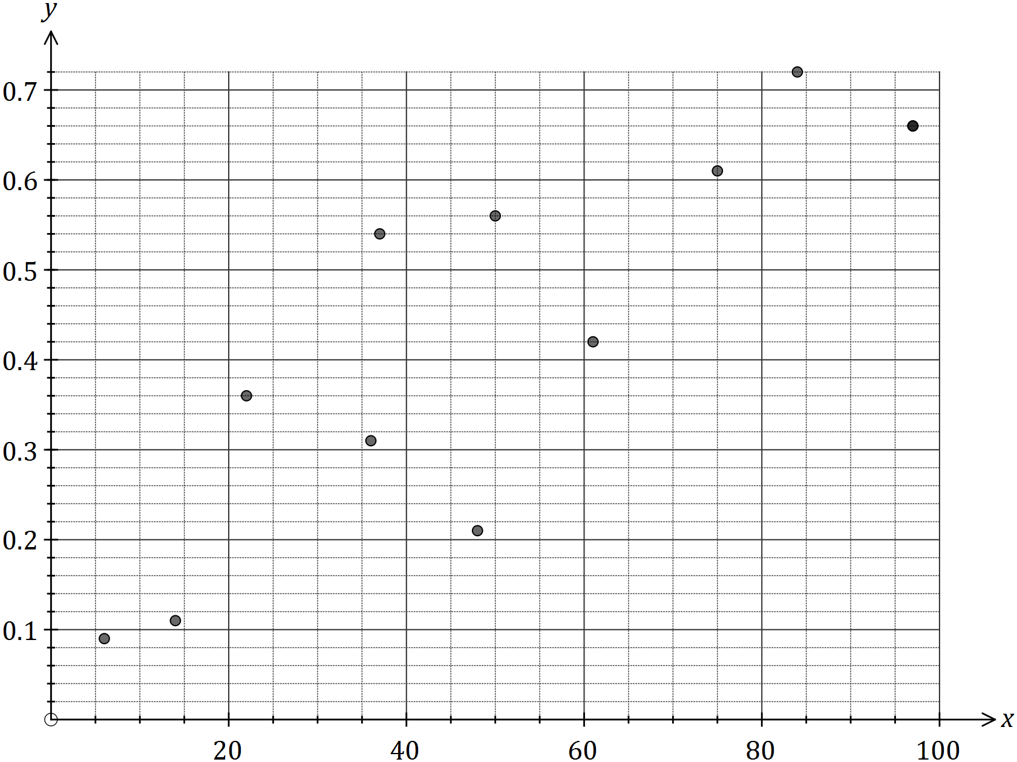

(a) Calculate the correlation coefficient for the data, and comment on how its value is reflected in the scatterplot above. (3 marks)

(b) What percentage of the variation in the yield can be explained by the variation in the rainfall? (2 marks)

(c) Determine the equation for the least-squares line that models the data. (2 marks)

(d) Draw the least-squares line on the scatterplot by first calculating two points that lie on the line. Clearly indicate these points. (3 marks)

(e) Estimate the cucumber yield in a season that has 64 mm of rainfall and comment on the reliability of this value. (3 marks)

Question 10 (7 marks)

The weighted graph below represents the footpaths connecting 12 buildings in the grounds of a defence force training facility. The number on each edge is the time required to walk along each footpath in minutes.

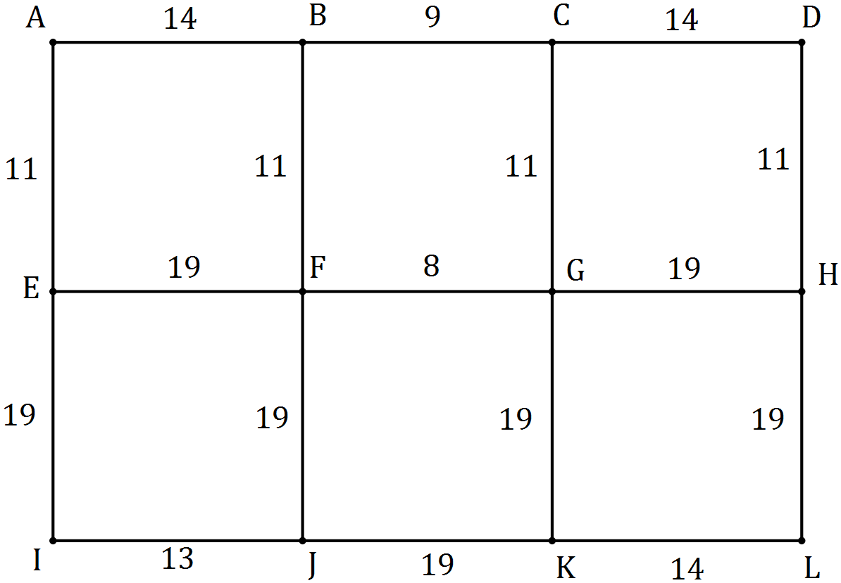

(a) Determine the minimum time to walk from $C$ to $J$ and state the corresponding route.

(2 marks)

(b) Determine the minimum time to walk from $A$ to $L$ and state the corresponding route.

(3 marks)

(c) A new footpath is being planned between $A$ and $D$ so that the time to walk from $A$ to $L$ is reduced by 5 minutes. How long should the walk between $A$ and $D$ take to achieve this? Justify your answer. (2 marks)

Question 11 (9 marks)

The value of a machine used in a factory is recorded at the start of each year.

|  |  |  |  |
| --- | --- | --- | --- |
| Year | 2014 | 2015 | 2016 |
| Value of machine ($) | 6 875 | 5 500 | 4 400 |

(a) Explain why the three values in the table form a geometric sequence. (2 marks)

(b) What is the annual percentage rate of depreciation of the machine? (1 mark)

Assume that the machine continues to depreciate at the same rate.

(c) Determine a rule for $V_{n}$, the value of the machine $n$ years after 2014. (2 marks)

(d) Determine the value of the machine at the start of the year 2020. (2 marks)

(e) The machine will be replaced when its value at the start of the year falls below $500. Determine which year this will be. (2 marks)

Question 12 (11 marks)

In a recent study of artists who asked for a piece of their work to be included in an exhibition, each artist was classified by the variables (i) the state they worked in and (ii) whether their piece of work was accepted by the judges.

The table below shows the number of artists in each category.

|  |  |  |  |  |  |  |
| --- | --- | --- | --- | --- | --- | --- |
|  | State | NSW | VIC | QLD | WA | Total |
| Work accepted? | Yes | 8 | 27 |  | 8 | 64 |
| No |  | 86 | 143 | 39 |  |
|  | Total |  |  |  |  | 440 |

(a) Complete the missing values and totals in the table above. (4 marks)

(b) To identify the presence of an association between these two variables, explain why the state the artist worked in should be used as the explanatory variable. (2 marks)

(c) Rounding percentages to the nearest whole number, complete the percentaged two-way table below so that it may be used to identify the presence of an association between the categorical variables. (3 marks)

|  |  |  |  |  |  |
| --- | --- | --- | --- | --- | --- |
|  | State | NSW | VIC | QLD | WA |
| Work accepted? | Yes |  |  |  |  |
| No | 93% |  |  |  |

(d) Comment on the presence of an association between the two variables. (2 marks)

Question 13 (8 marks)

A simple connected graph is drawn below.

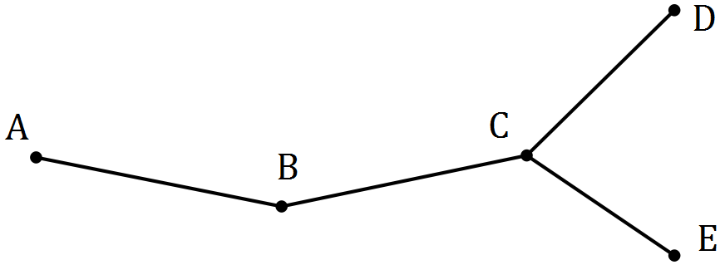

(a) List, in order, the vertices of a closed walk on the graph of length 8 that visits all vertices and ends at A.

(2 marks)

(b) Explain why the walk in (a) is not a Hamiltonian cycle. (2 marks)

(c) Add one edge and one face to the copy of the graph below, so that the new graph contains a Hamiltonian path and mark this path on the graph. (2 marks)



(d) Add two edges and two faces to the copy of the graph below, so that the new graph does not contain a Hamiltonian path or cycle. (2 marks)



Question 14 (6 marks)

A student was trying to decide whether fitting a linear model to their data was an appropriate choice. They calculated the least-squares line through the 30 points to be $\hat{y}=2.4x-12.5$ and the correlation coefficient $r=0.98$.

(a) Explain why constructing a residual plot would help the student decide. (2 marks)

The residual plot for the student's data is shown below.

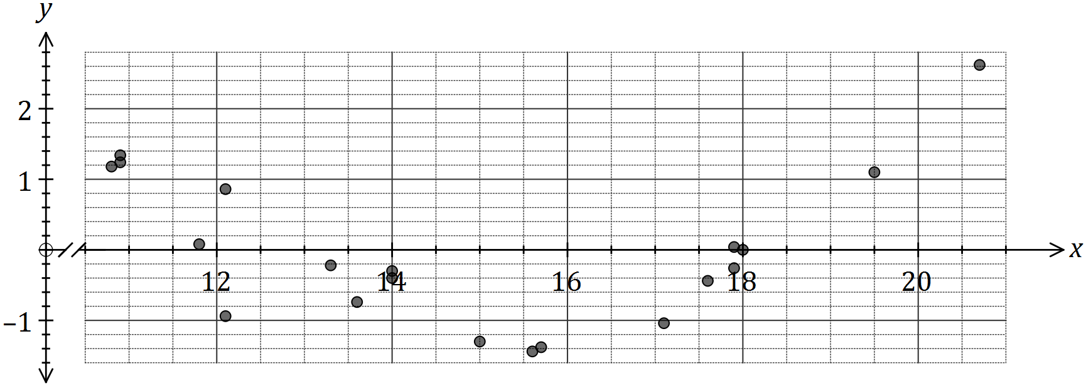

(b) One residual is missing from the plot, corresponding to the original data point $(20.5, 37.3)$.

Calculate the residual for this point and add it to the residual plot. (3 marks)

(c) What conclusion should the student draw about the appropriateness of the linear model?

(1 mark)

Question 15 (9 marks)

The graph below represents 14 canals that meet at locations $A$ to $H$.

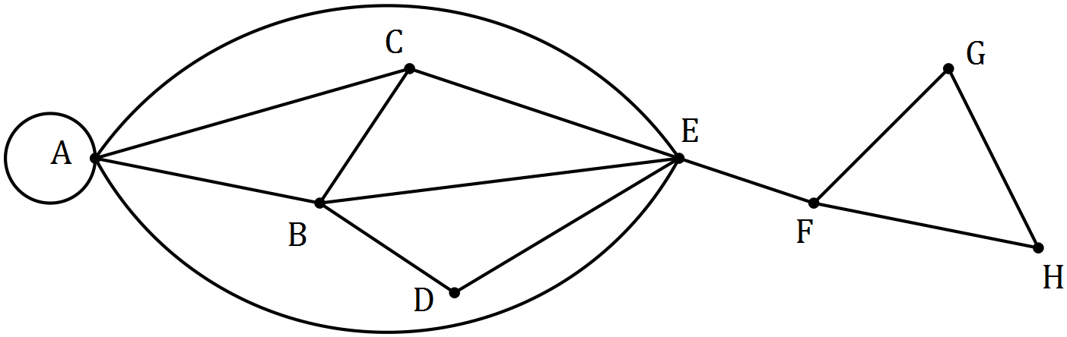

(a) A canal enthusiast noticed that the graph contained a semi-Eulerian trail. State the two properties of a walk that make a semi-Eulerian trail. (2 marks)

(b) What property of a connected graph indicates the existence of a Eulerian trail, a semi-Eulerian trail or neither? (2 marks)

(c) Suggest a suitable starting point for the canal enthusiast to begin a semi-Eulerian trail and indicate where they will finish the trail. (2 marks)

(d) Draw a subgraph of the above graph that is simple, connected, has no bridges and has 8 edges. (3 marks)

Question 16 (9 marks)

Following the analysis of data collected from a group of women aged between 22 and 38, a strong, linear relationship between their age ($x$, in years) and percentage chance of conception ($y$, percent) in any given month was observed. The coefficient of determination between the variables was 0.87 and the equation of the least-squares line was $\hat{y}=-0.88x+45.8$.

(a) Determine the correlation coefficient between $x$ and $y$. (2 marks)

(b) Estimate the monthly percentage chance of conception of a woman aged

(i) 18 years. (1 mark)

(ii) 35 years. (1 mark)

(c) Comment, with reasoning, on the reliability of each of your estimates in (b). (3 marks)

(d) Describe the meaning of the slope of the least-squares lines in the context of this question. (2 marks)

Question 17 (12 marks)

As part of a trial to reintroduce woylies (an endangered species of mammals) to a wildlife reserve, researchers modelled the expected size of a woylie population, $P_{n}$, using the rule below where $n$ is the number of months since the trial began.

$$P_{n+1}=0.85P_{n}+30, P_{0}=20.$$

(a) State

(i) the size of the woylie population at the start of the trial. (1 mark)

(ii) the number of woylies added to the reserve each month. (1 mark)

(iii) the percentage loss of existing woylies in the reserve each month. (1 mark)

(b) Complete the missing values in the table below to show the expected number of woylies over the first six months. (2 marks)

|  |  |  |  |  |  |  |  |
| --- | --- | --- | --- | --- | --- | --- | --- |
| $$n$$ | 0 | 1 | 2 | 3 | 4 | 5 | 6 |
| $$P_{n}$$ |  |  | 70 | 89 | 106 |  |  |

(c) Determine the expected size of the woylie population after three years. (2 marks)

(d) Graph the population of woylies on the axes below for $0≤n≤12$. (3 marks)

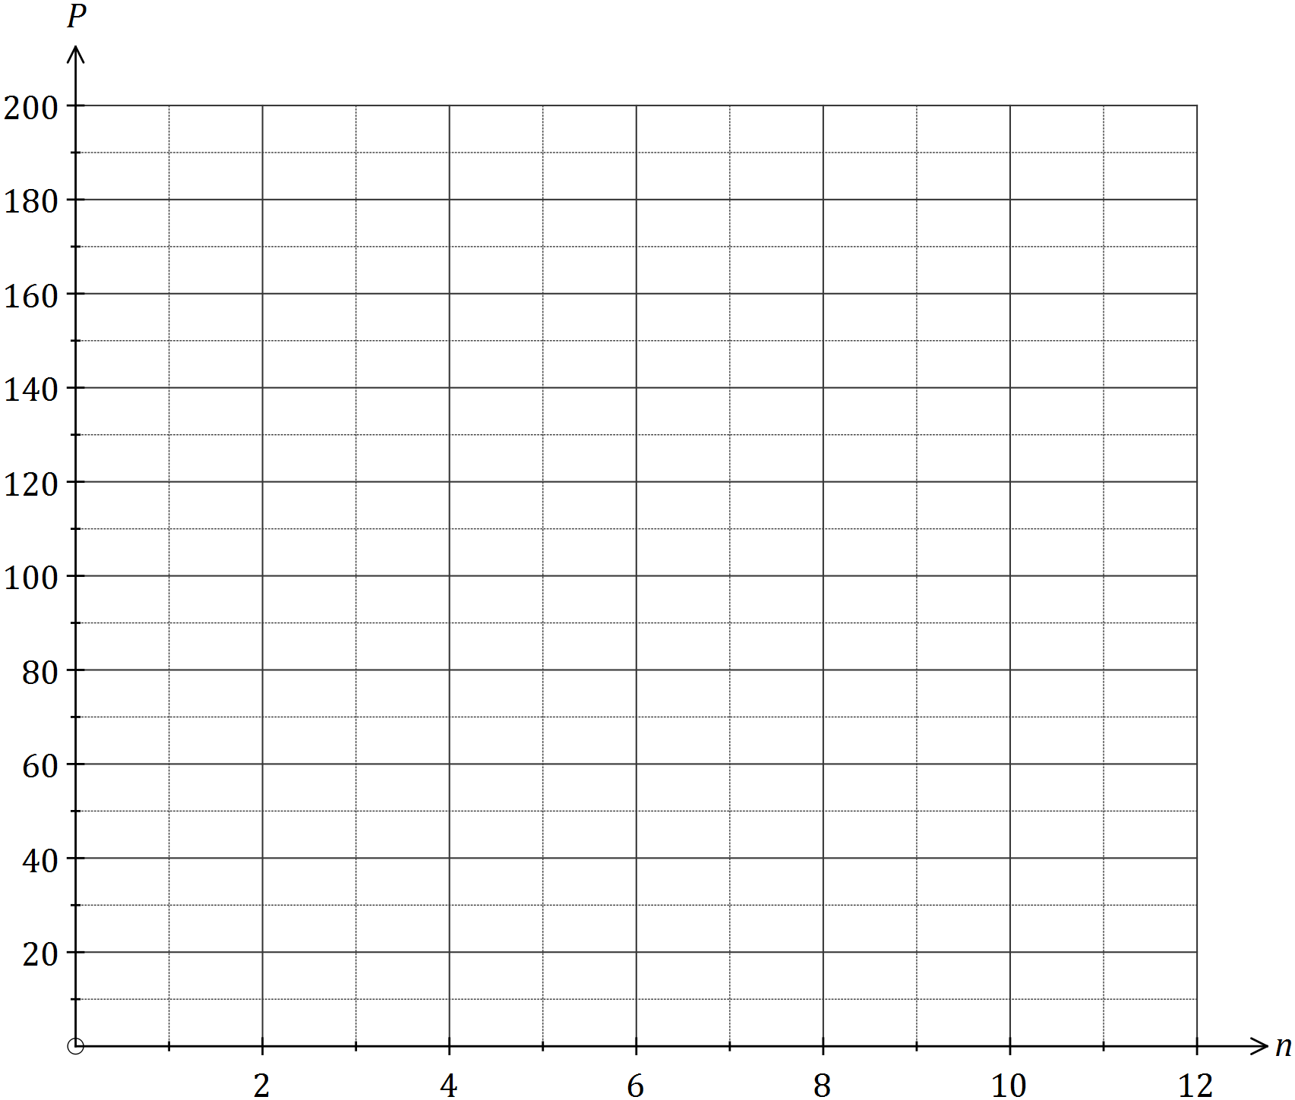

(e) Use the model to describe how the size of the woylie population in the reserve will change over the first three years. (2 marks)

Question 18 (8 marks)

Five children ($A, B, C, D, E$) are playing a game of hide and seek. The directed edges, shown in the adjacency matrix $M$ below, represent whether the child in a row knows the location of the child in a column.

|  |  |  |  |  |  |
| --- | --- | --- | --- | --- | --- |
| $$M$$ | $$A$$ | $$B$$ | $$C$$ | $$D$$ | $$E$$ |
| $$A$$ | 0 | 1 | 1 | 0 | 0 |
| $$B$$ | 0 | 0 | 1 | 0 | 1 |
| $$C$$ | 0 | 0 | 0 | 1 | 1 |
| $$D$$ | 1 | 1 | 0 | 0 | 0 |
| $$E$$ | 0 | 0 | 0 | 1 | 0 |

(a) Construct a digraph to show the above information. (3 marks)

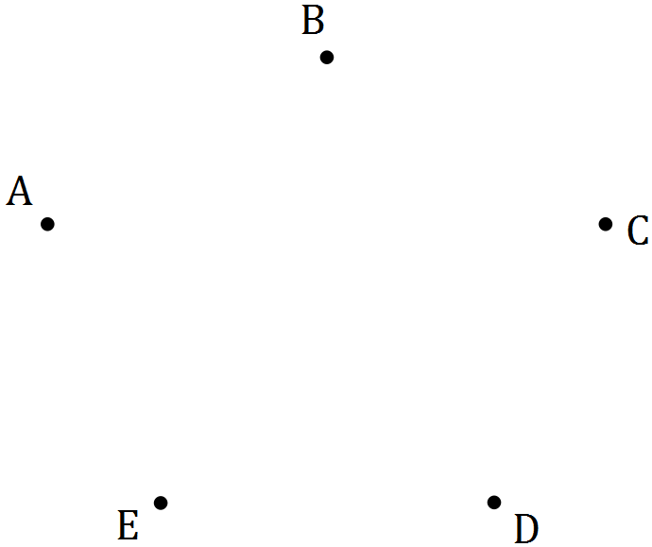

(b) Calculate the matrix $M^{2}$. (1 mark)

(c) If child $D$ wanted to locate child $E$ with the help of one other child, could they? Explain how an element of $M^{2}$ can help justify your answer. (2 marks)

(d) Two children are unable to locate all the other children, even with the help of one other child. Who are these two, and who can't they locate? (2 marks)

Additional working space

Question number: _________

Additional working space

Question number: _________

Additional working space

Question number: _________

© 2016 WA Exam Papers. Mercedes College has a non-exclusive licence to copy and communicate this paper for non-commercial, educational use within the school. No other copying, communication or use is permitted without the express written permission of WA Exam Papers. SN064-096-3.